**东华大学学报**

2025年第42卷第4期

──────────────────────────────

*本期责编: 编辑部 | 2025年10月31日*

**1. 基于四丁基四氟硼酸铵修饰的导电炭黑开发头孢羟氨苄抗生素电化学传感器**

朱宗贤, 张煊

*论文配图:*

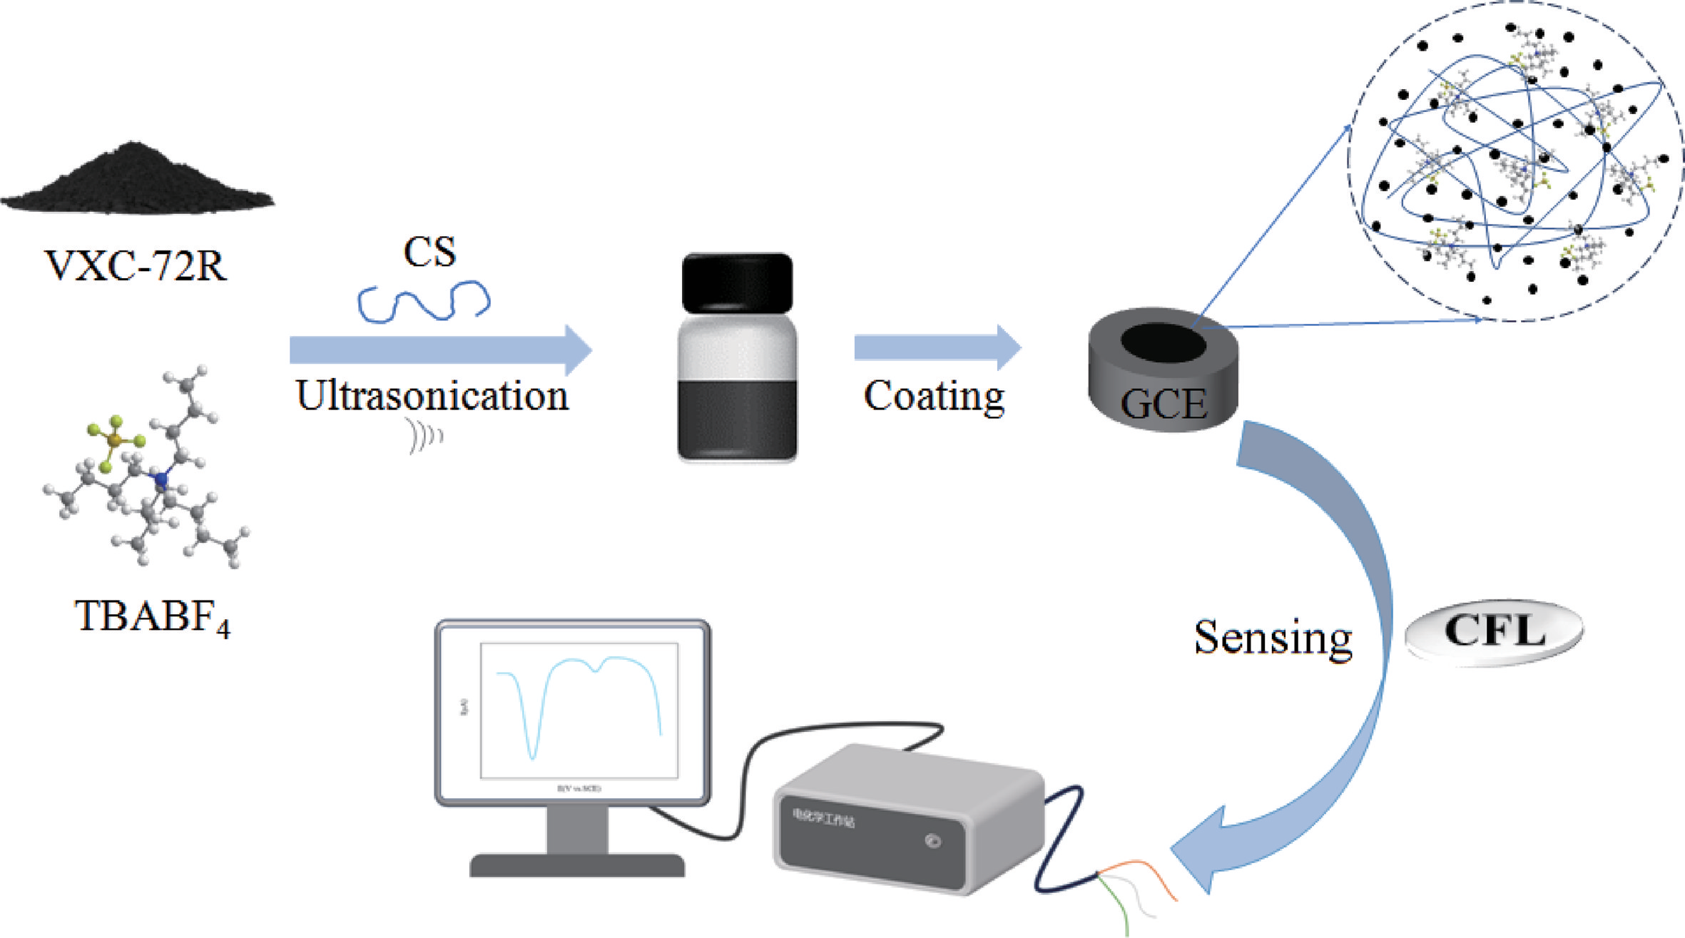

**Development of Electrochemical Sensor for Cefadroxil Antibiotic Based on Conductive Carbon Black Decorated with Tetrabutylammonium Tetrafluoroborate**

ZHU Zongxian, ZHANG Xuan

DOI: 10.19884/j.1672-5220.202406006

Citation: ZHU Z, ZHANG X. Development of Electrochemical Sensor for Cefadroxil Antibiotic Based on Conductive Carbon Black Decorated with Tetrabutylammonium Tetrafluoroborate [J]. Journal of Donghua University (English Edition), 2025, 42(3): 348-357.

────────────────────

**作者说链接/OSID**

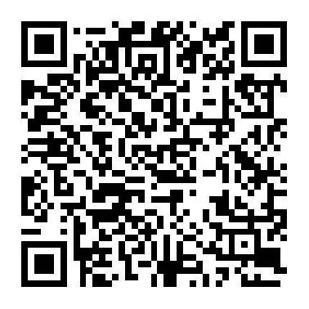

──────────────────────────────

感谢您的阅读！欢迎引用本文内容

© 2025 东华大学学报 版权所有